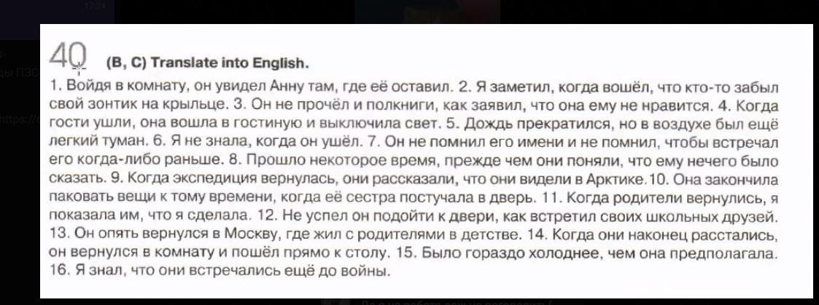
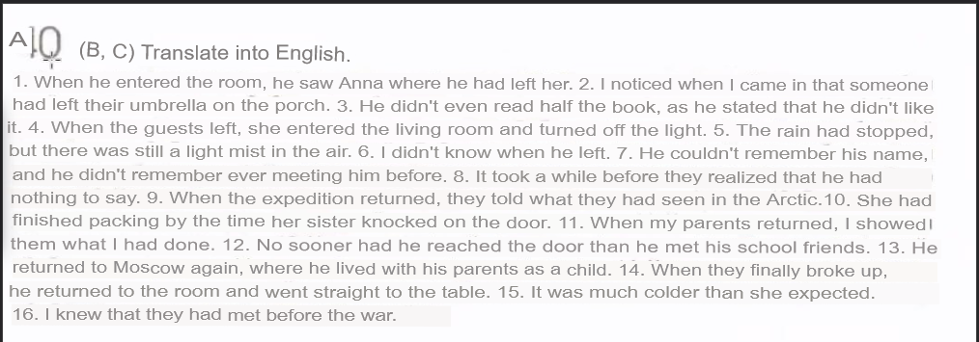
1)When he entered to room, he saw Ann where he had left it
2)When someone came, I saw that somebody forgot umbrella on the porch
3) He hadn’t ridden a half if book, when he said that he didn’t like it.
4) When guests had left, she entered the living room and turned off light.
5)The rain had stopped, but light mist still was in the air.
6)She wasn’t knew, when he had left.
7) He wasn’t remember his name and didn’t remember that he met him before
8) Some time left when they understood that he hadn’t anything to seen.
9) When expedition had come, they said what they had seen in Antarctic.
10)She had stopped packing bags when sister knocked on door.
11) When parents came, I showed them what I had done.
12) He hadn’t time to came to door when he met his school friends;
13)He came to Moscow again where he had lived with parents.
14)When they had finaly broke up, he returned to room and came to table
15)I was colder than she had expected.
16)I knew that they had met before war.

